CALL for Artists
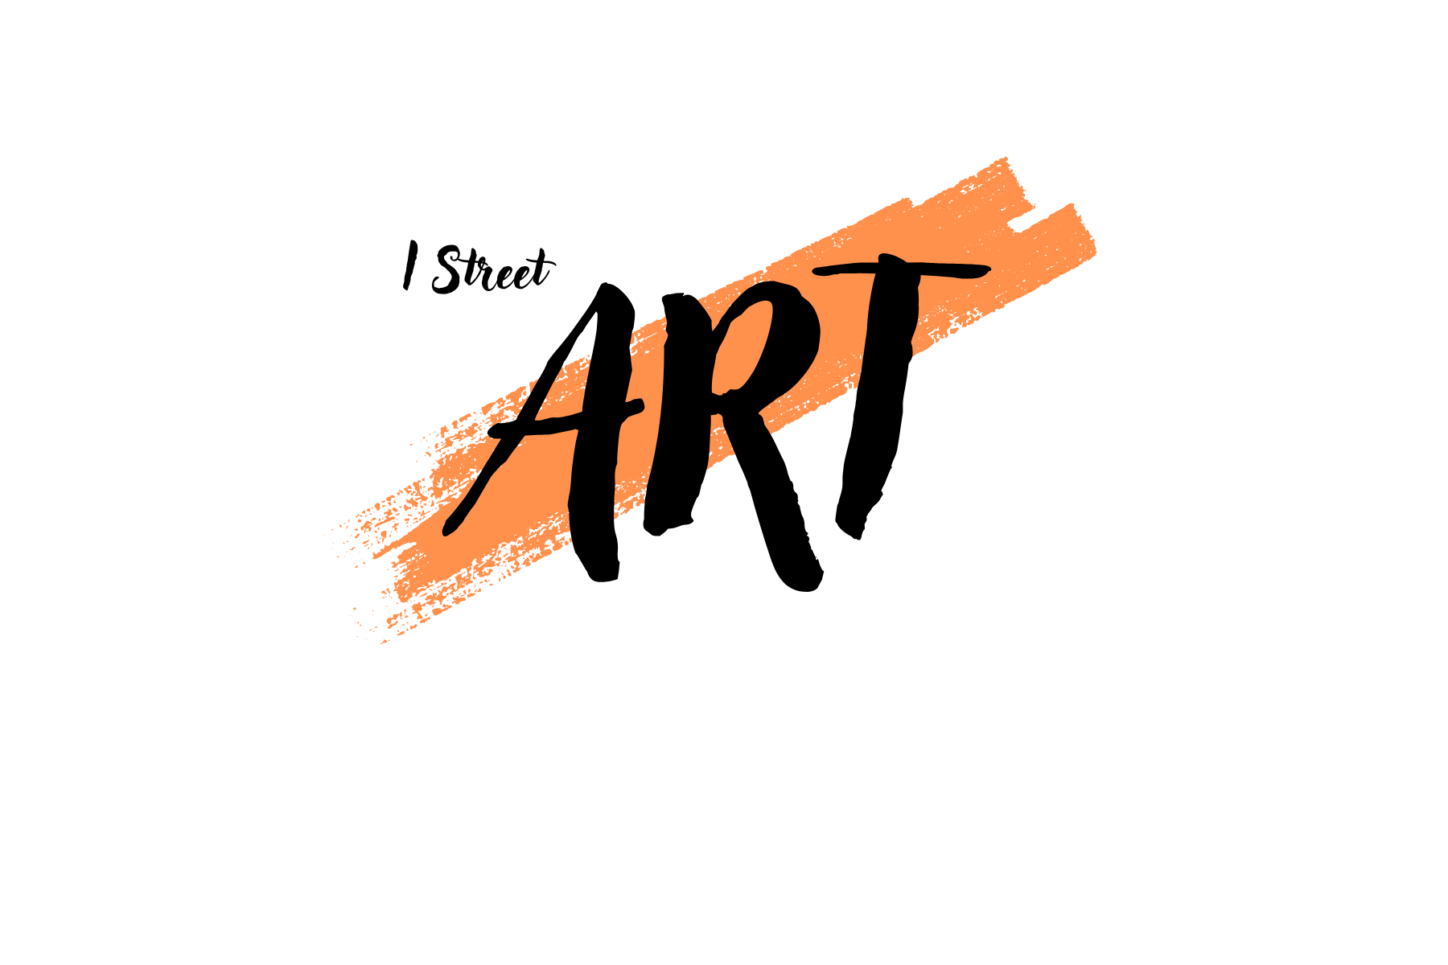
2nd Annual July Midtown Open Art Show at I Street Art

Sacramento area artists are invited to participate in The Gems of Midtown, the July 11-12 Saturday/Sunday Art Show, at the I Street Art Studios, 1727 I Street, Sacramento CA 95811. The show will be included on the Midtown 2nd Saturday Art Walk and will be cosponsored by the Midtown Association. Best of show awards and prizes will be given by the Midtown Association to recognize works that showcase Midtown and/or are judged to have exemplary artistic/creative merit.

MIDTOWN AREA: 16th to Alhambra
C Street to R Street

I Street Art Studios is inviting local artists to create original artwork(s) depicting the “Gems” of Midtown. This can include an iconic or local view found in Midtown, to include events, activities, businesses, locations, interesting buildings and images. What are the special places or ones that evoke memories? This art show seeks to capture the spirit of Midtown! Both 2D and 3D works are acceptable, as is abstraction, expressionism and, of course, realism. All media are acceptable. All works must be gallery ready. Wall art must be framed or on canvas at least 1/2 in thick or in a gallery acceptable form, ready to be hung with wire attached and ends wrapped. (No sawtooth hangers.). There will be a submission fee of $10* per artwork, paid at the time of drop-off. More than one artwork per artist is welcome. Please secure pre-approval for very large or heavy artworks from chair, Lori Franz, or email istreetartstudios@gmail.com. Items displayed at the 2025 Iconic Midtown Art Show are not eligible for submission.

All works can be listed with a price or NFS. No commission on sales is charged by the I Street Art Studios, although you must handle your own sales or ask someone to handle them for you. We will make your phone/text available to buyers requesting that information. You may place a Venmo/Zelle QR code on the back/underside of your work, if you allow Venmo/Zelle sales. No works can be removed from the show until 10 minutes after show closure.

All artists wishing to participate in the show must register their intent. There is a “brainstorming list” on the website which you can use to inspire you. We do need registrations from participating artists by July 6. Our show space is large, however, we reserve the right to close off registration if our capacity is exceeded or to decline artworks whose reference is clearly outside the Midtown area.

Only those who are registered are invited to participate. They will receive additional information about the show, drop-off times and a link to create a label for each artwork in an email at the end of June. To register, please click this link: https://forms.gle/cT11i28kfS4rtyf6A Register once for each artwork you will submit. Information about I Street Art Shows and for artists can be found at our website: www.Istreetartstudios.com To contact us by email use istreetartstudios@gmail.com

We are looking forward to a great show!

*waived for resident and affiliate members of I Street Art Studios.

